**FULL ADDER**

**EXP NO: 16**

**AIM:** To design and implement full adder using Logisim simulator.

**ALGORITHM:**

1. Connect two inputs to the X-OR gate and one input to AND gate.
2. Connect those inputs to all other gates.
3. Start the connection on AND and X-OR gates, finish it reaching the designated inputs.
4. Connect the output to the gates
5. Check and verify the truth table accordingly.

**DIAGRAM:**

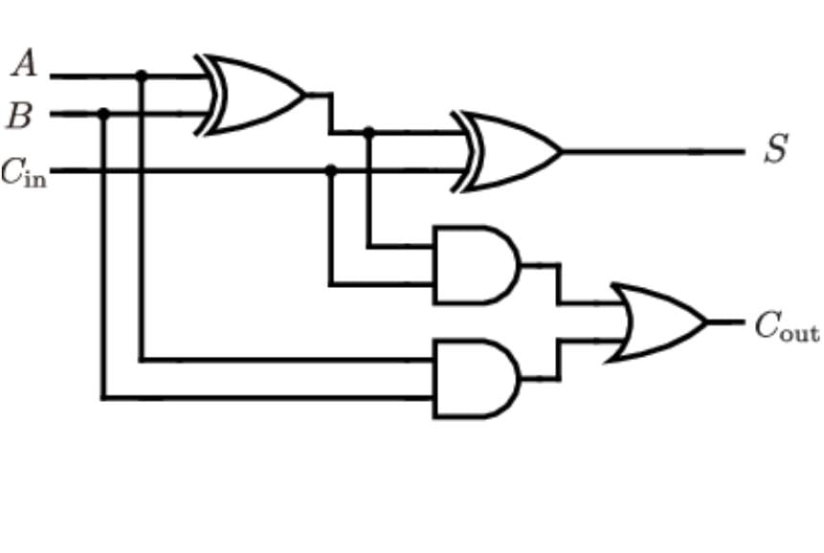

**TRUTH TABLE:**

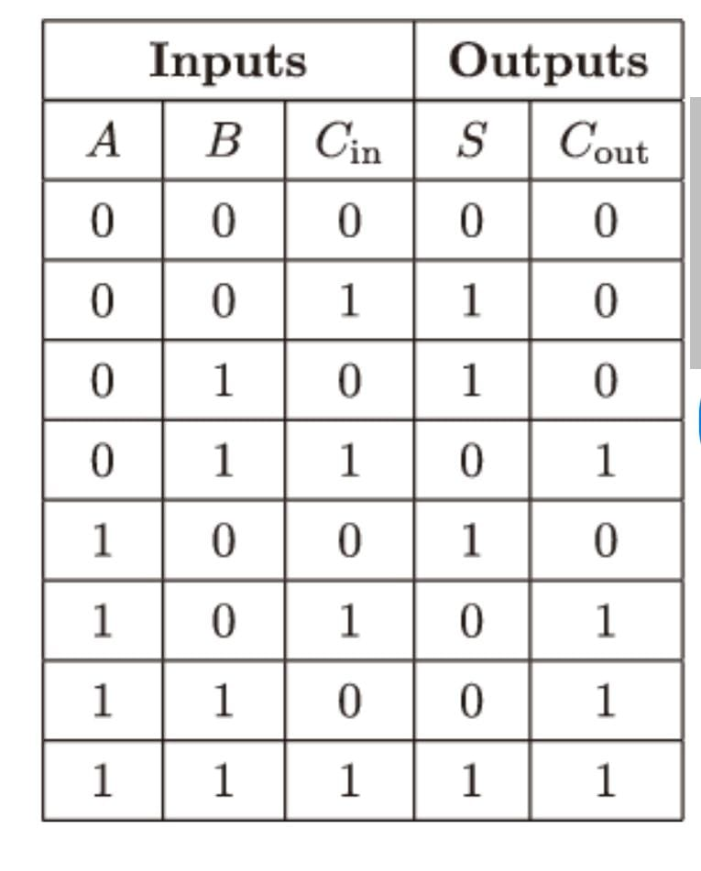

**OUTPUT:**

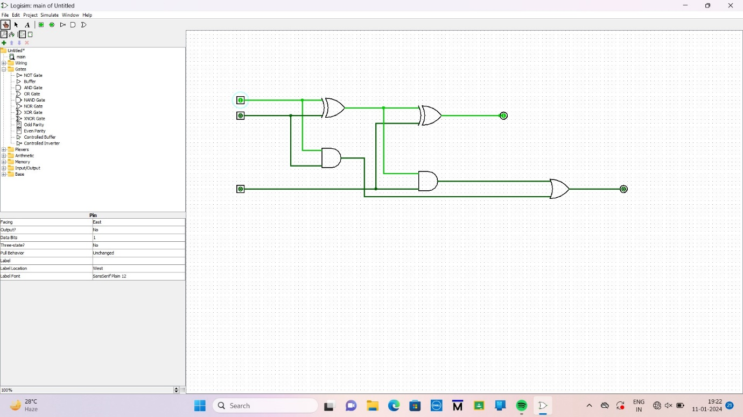

**RESULT:** The implementation of full adder using Logisim simulator was executed successfully.